**IVEN Use in Python (Windows [cmd] and Mac [terminal])**January 2020  
Jessica E. Forsyth

This tutorial outlines how to use IVEN in the Python platform. Before starting this, make sure you read how to organise your data in the ‘Data Assembly for Input into IVEN Pipeline’ tutorial.

Python version-

IVEN was written to work with Python3. To download the latest version, go to <https://www.anaconda.com/distribution/>, (at the time of writing the tutorial, the most recent download is for version 3.7). Once downloaded you are ready to run IVEN.

Interpreter/Code Editing- (you don’t need this unless planning to edit IVEN code) I use PyCharm to run Python scripts as I find this easier, and clearer when editing code. To download PyCharm go to <https://www.jetbrains.com/pycharm/download/#section=windows>, and download the free community version. Once downloaded go through the options and set PyCharm up for your personal preference. (or use Jupyter notebook included in the Anaconda download)

1. Double check your data is in the correct format with correct columns and column order (pad your data if need be). See ‘Data Assembly for Input into IVEN Pipeline’ tutorial.
2. Download the .py files from our GitHub; ‘final_data_display.py’, ‘funcs.py’ and ‘run_IVEN.py’. Save these files into a folder on your computer. Make sure they are easily accessible and you know where they are located.
3. **Windows:** First go to your search bar (where the start button used to be), and type ‘Anaconda Prompt’, you should see the App displayed for the Anaconda terminal, Figure 1. Click this.  
   **Mac:** Go to Utilities>>Terminal.
4. 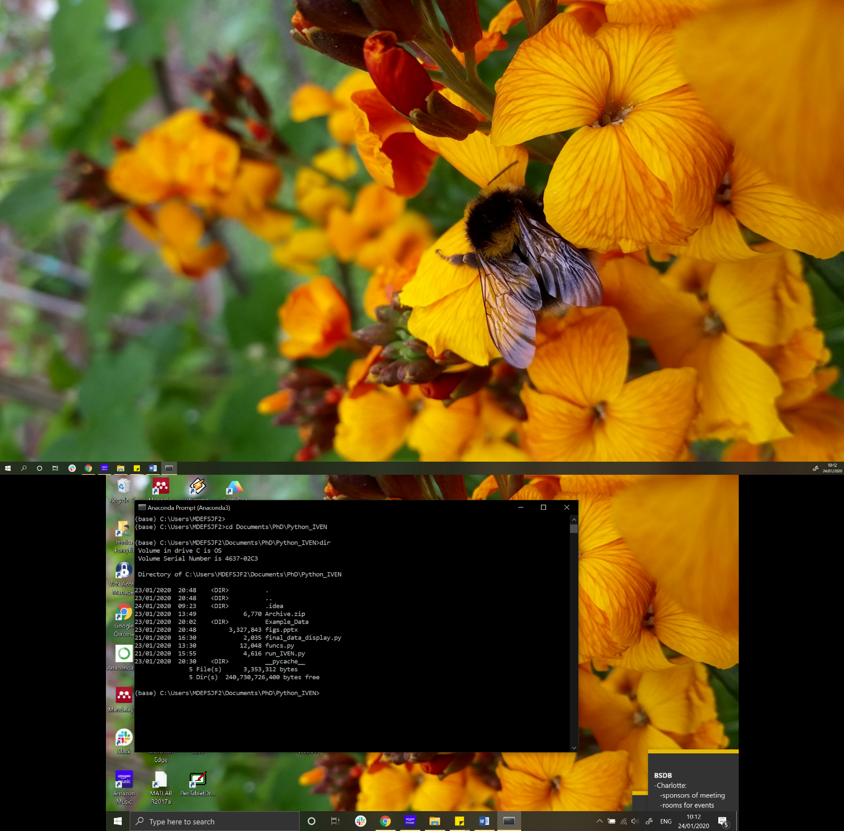**Windows:** Once you have opened this, you should see the standard command line interface, displaying where you currently are in your directory (e.g. Users/Jess). Now navigate to where you have saved the IVEN ‘.py’ files, using ‘cd’, Figure 2. Display all files within the current directory using ‘dir’, Figure 2.

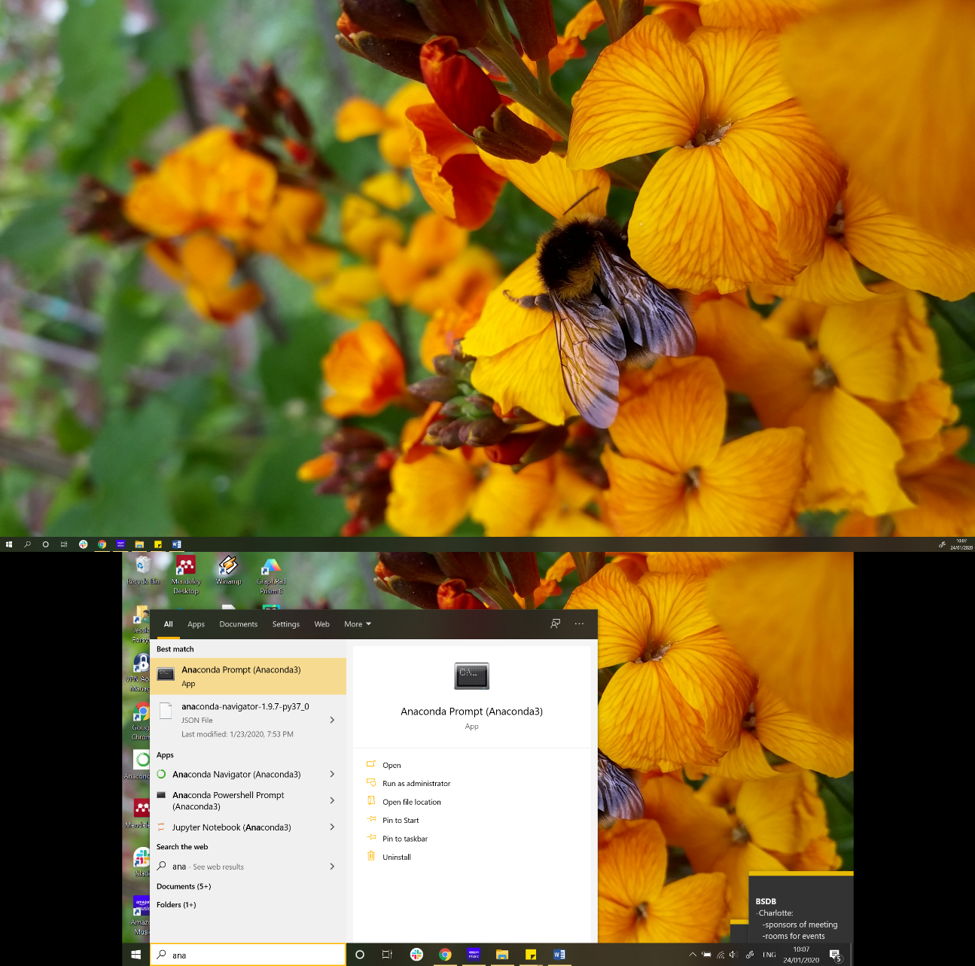

Figure 2 Command line file navigation and file display in the Anaconda prompt, Windows.

Figure 1 Open the Anaconda command line terminal. This will be downloaded with Anaconda, Windows.

**Mac:** You should see you standard bash terminal. Like for Windows machines, use ‘cd’ to navigate to where you have saved the IVEN ‘.py’ files. To check the files within a given directory type ‘ls’, this should show you all files in the current working directory.

**From now on, all steps are the same for Windows and Mac operating systems!**

1. To run IVEN, type python run_IVEN.py and press Enter.
2. A file directory should pop up, locate the excel file of the embro/sample you would like to analyse, and press Open.
3. A three dimensional plot of cell points (marked by grey circles) should now be displayed. This is your embryo/sample! Rotate the embryo by clicking on the plot and dragging the plot around.   
     
   Circles outlined in black are identified as outside cells (using the Convex Hull).  
   Circles outlined in white are identified as inside cells.   
   To change the classifications of cells, simply click on the circles. You should see that the circle’s outline will change to black or white. This is the manual correction of the cell classification. *Figure 3.*  
     
   If you have channel data that helps identify outside cells, for example in the preimplantation embryo- CDX2. Display the corresponding relative channel intensities by pressing ‘g’, ‘r’ or ‘i’ on the keyboard to display the green, red and far-red channels respectively. *Figure 3.*

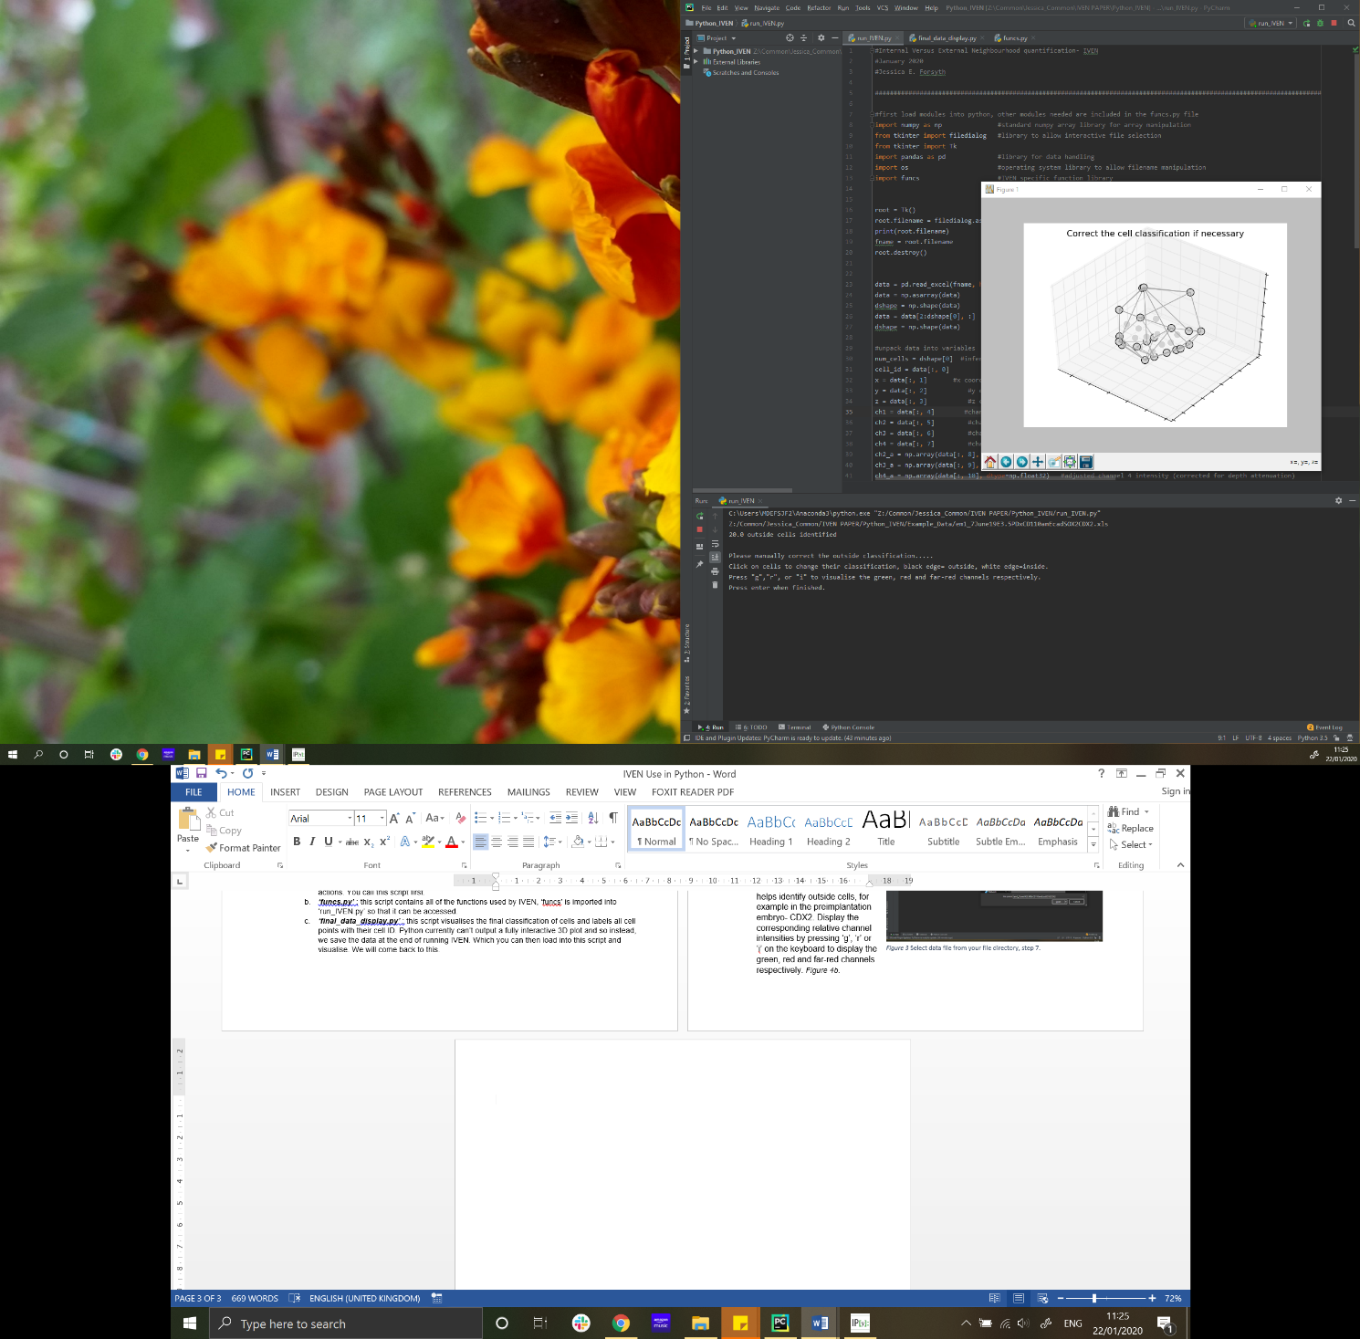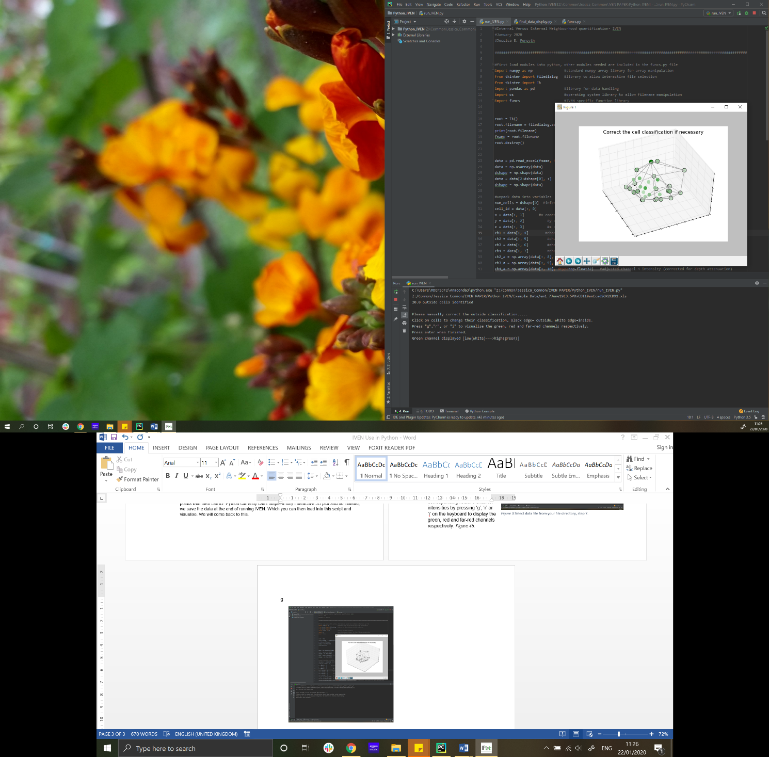

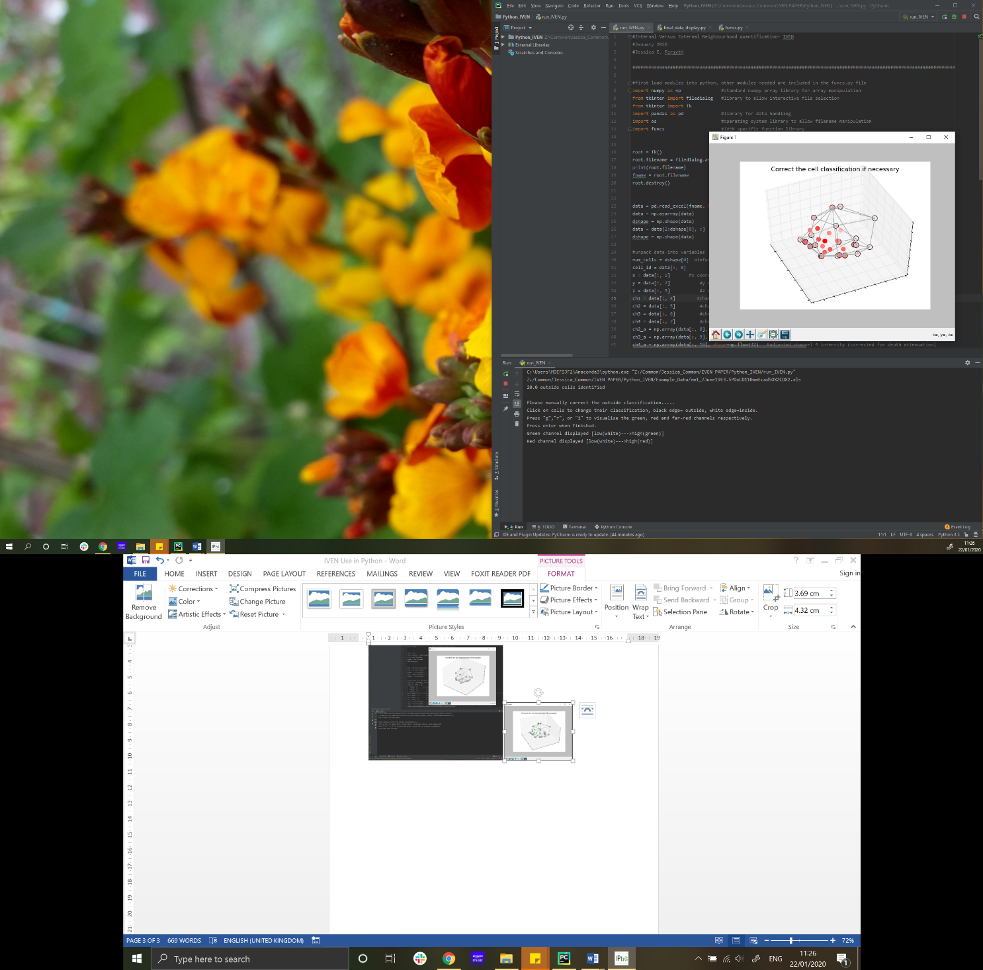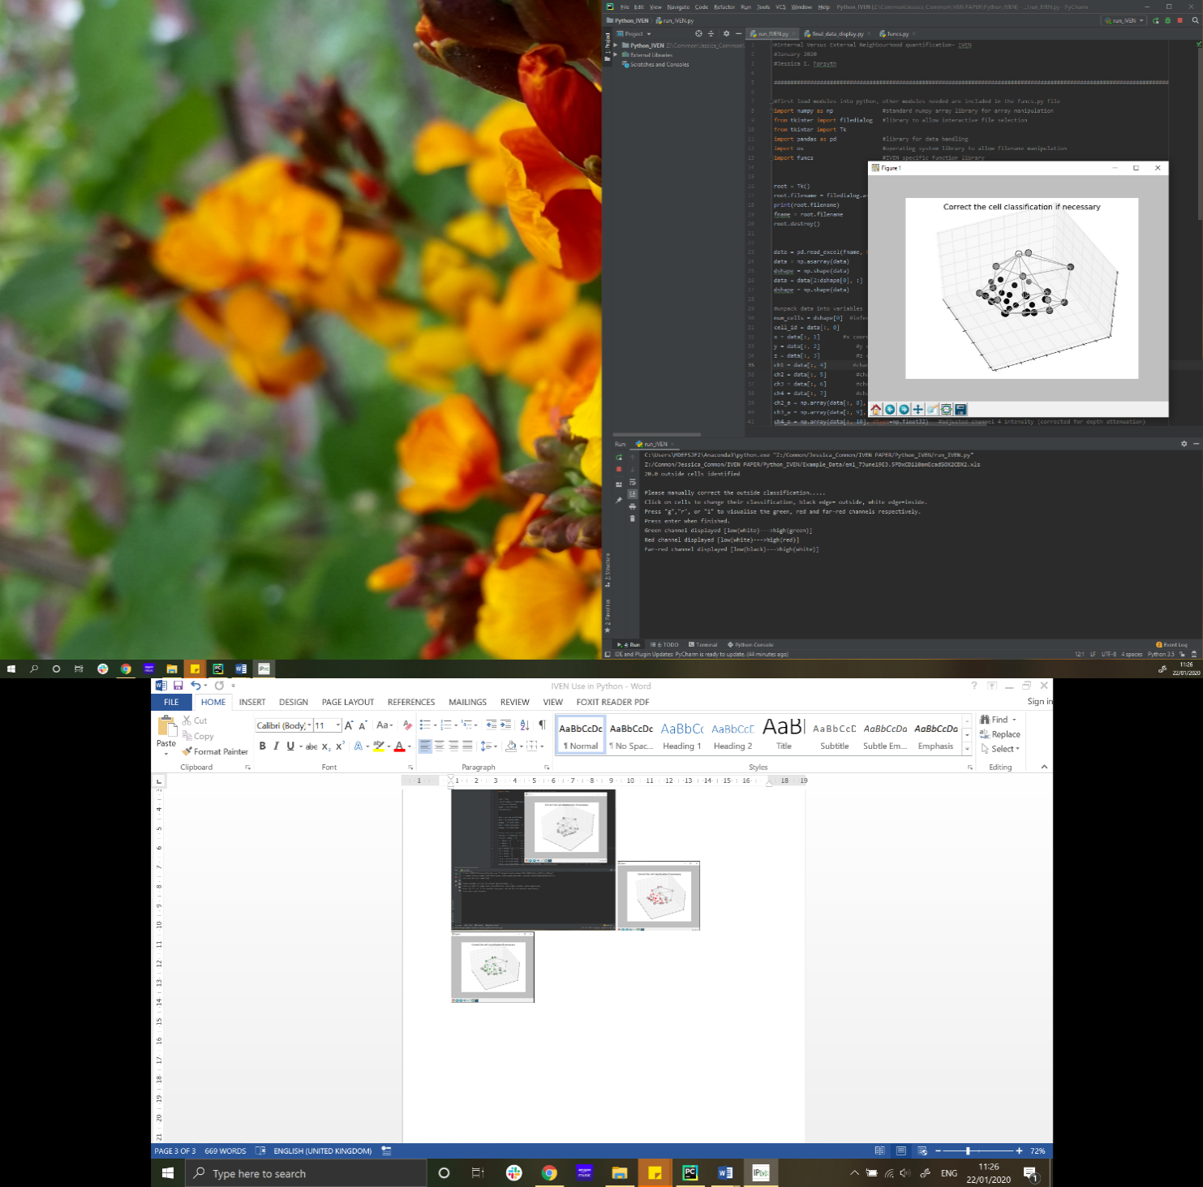

Figure 3 Initial display of cell centres and mesh of Convex Hull, step 8, plus green, red and far-red channels shown to help with cell classification correction.

1. Once you have finished checking the classification of the cells as either outside or inside, press Enter.
2. 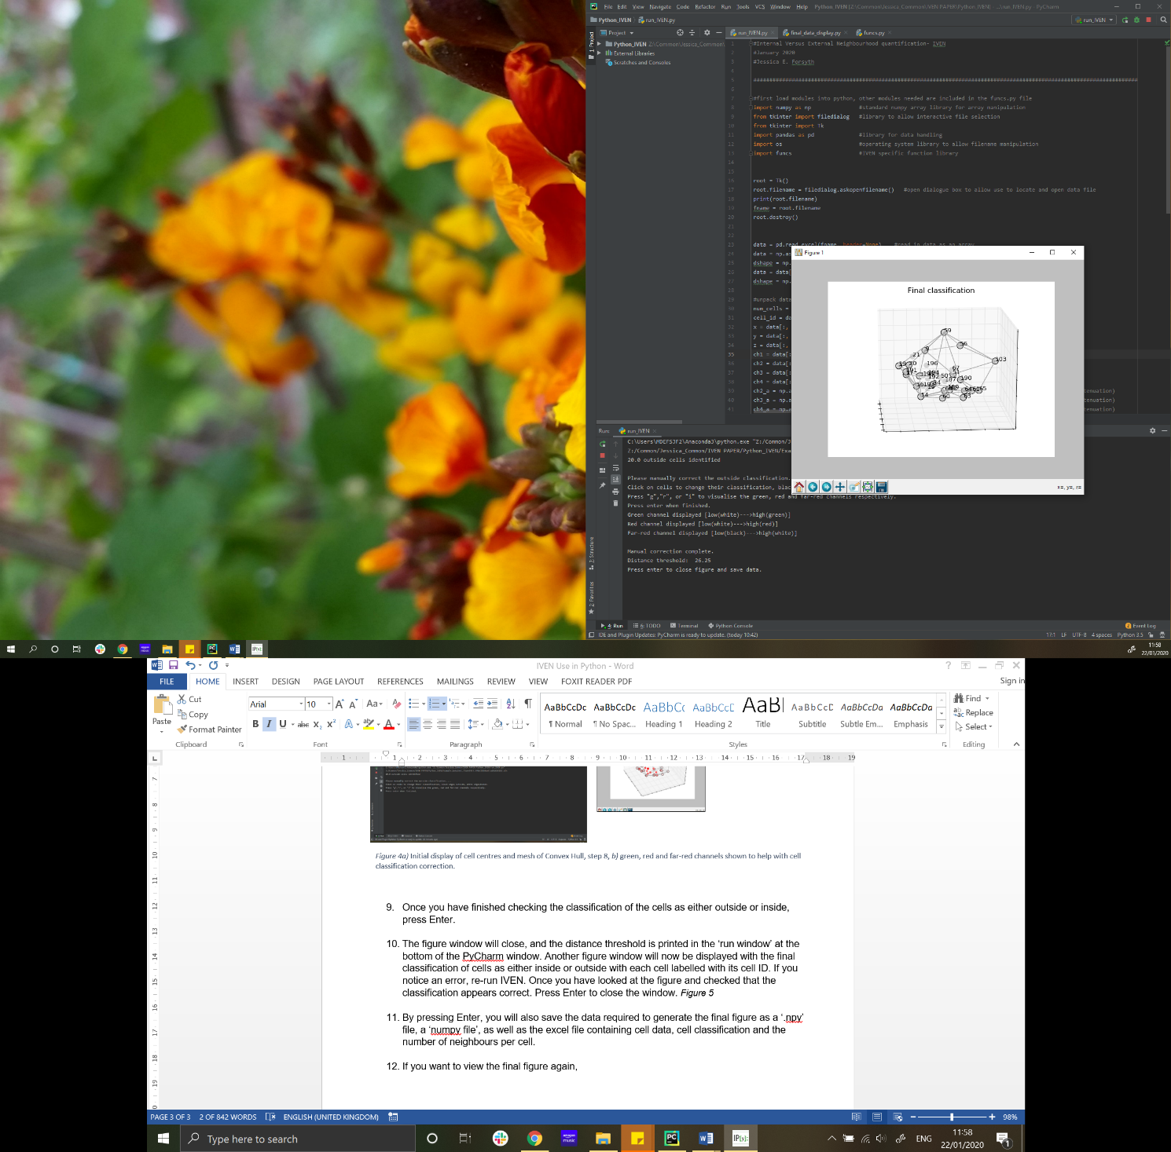The figure window will close, and the distance threshold is printed in the ‘run window’ at the bottom of the PyCharm window. Another figure window will now be displayed with the final classification of cells as either inside or outside with each cell labelled with its cell ID. If you notice an error, re-run IVEN. Once you have looked at the figure and checked that the classification appears correct. Press Enter to close the window. *Figure 4*
3. By pressing Enter, you will also save the data required to generate the final figure as a ‘.npy’ file, a ‘numpy file’, as well as the excel file containing cell data, cell classification and the number of neighbours per cell. The final data file is saved as ‘*nbrs_.......original_filename.xls’*.

Figure 4 Final clasification of cells and labelled cell ID, step 10.

1. If you want to view the final figure again, type ‘final_figure_display.py’ in the command line in the same directory, and press Enter. Your file directory will open again, locate and select the ‘.npy’ file you want to open and press Open. This will open the final figure so that you can rotate the embryo and map cell IDs and locations to the data in the ‘nbrs_....xls’ excel spreadsheet. Close the figure when you are finished. Any time you want to view the figures again, you must navigate to where the IVEN .py files are saved and run ‘final_figure_display.py’ .